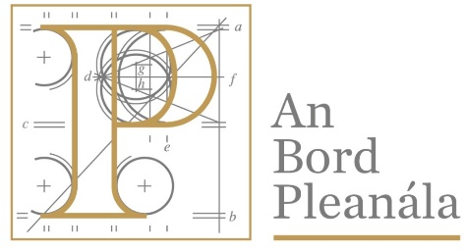 | Board Meeting Record
 | ABP-318444-23

General:
ABP Case No.: ABP-318444-23
Meeting: BM-004033-24
Meeting Date: 02/05/2024
Meeting Location: Office of An Bord Pleanála
Board Meeting Record Signed Off: Yes
Attendees:
Una Crosse
Patricia Calleary
Liam Bergin

ABP Case:
Inspector: Vanessa Langheld
Board Member: Liam Bergin
Case Type: Normal Planning Appeal PDA2000
Development Address: 4, Abbey Park, Monkstown, Co. Dublin.
Development Description Summary: Construction of two new two-storey dwellings with attic levels within the side garden of the existing house and all associated site works.

Decision:
Inspector Recommendation Accepted? Generally Accepted
Conflict of Interest Identified? No
If Yes, Reason for Conflict of Interest:
Meeting Outcome: Decision Made
Decision: Grant permission
Split Vote: No
If Yes, Ratio:
Discussion Details:

Board Member 1 - Sign off  Signed Off By: Una Crosse  Date Signed: 02/05/2024 | Board Member 2 - Sign off  Signed Off By: Patricia Calleary  Date Signed: 02/05/2024

